Return to Activity and Habitat Biome Usage of Nine Bat Species in Alberta, Canada on the Property of the Cochrane Ecological Institute

This investigation covers the return to activity of nine bat species present in Alberta, Canada after their hibernation or migrations and their use of the five different habitat biomes present at the Cochrane Ecological Institute.

Internship Project for the program Animal Management at the Van Hall Larenstein University of Applied Sciences in Leeuwarden, The Netherlands

Cochrane in Alberta, Canada
August 2022

Judith Jonkers
Supervisor: Ken Weagle

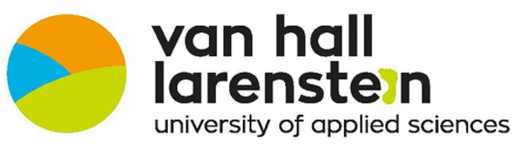

Abstract
This investigation report looks into the timing of return to activity for the nine bat species present in the province of Alberta in Canada as well as the usage of the five different habitat biomes that are present on the property of the Cochrane Ecological Institute, situated in Alberta, Canada. Using a song meter mini bat recorder provided by Wildlife Acoustics, individual bat calls were recorded to get a general idea regarding which bat species are present on the property and in which locations they could be found in the highest abundance. Most of the bat species present in the Alberta province in Canada return to activity around the end of May and beginning of June. The Hoary Bat (Lasiurus cinereus) was recorded the most with 1332 total bat calls. Its highest abundance was in the aquatic and wetland habitat biomes. The Northern Long-Eared Myotis (Myotis septentrionalis) was recorded the least number of times with a total of 16 bat calls, mainly in the mixed forest habitat biome.

Table of Contents
1 Introduction 4
1.1 Objectives 7
2 Materials & Method 8
2.1 Materials 8
2.2 Method 9
2.3 Time Frame 11
3 Data Analysis 12
3.1 Overview 16
3.2 Big Brown Bat (Eptesicus fuscus) 17
3.3 Eastern Red Bat (Lasiurus borealis) 18
3.4 Hoary Bat (Lasiurus cinereus) 18
3.5 Silver-Haired Bat (Lasionycteris noctivagans) 19
3.6 Western Small-Footed Myotis (Myotis ciliolabrum) 19
3.7 Western Long-Eared Myotis (Myotis evotis) 20
3.8 Little Brown Bat (Myotis lucifugus) 21
3.9 Northern Long-Eared Myotis (Myotis septentrionalis) 21
3.10 Long-Legged Myotis (Myotis volans) 22
3.11 Weather 23
4 Conclusion 29
4.1 Return to Activity 29
4.2 Habitat Biome Usage 30
4.3 Weather Effect 30
5 Limitations 32
6 Further Research 33
7 Works Cited 34
8 Appendix I: Settings for song meter mini bat recorder i
9 Appendix II: Call frequency of the bat species expected in the province Alberta, Canada iii

Introduction
In 2014, the province of Alberta launched a pilot project to expand the research environment of the Northern American Bat Monitoring Program (NABat) into Canada (Burgar, 2021). The NABat’s purpose is to “create a continent-wide program to monitor bats at local to range-wide scales that will provide reliable data to promote effective conservation decision-making and the long-term viability of bat populations across the continents” (Loeb, et al., 2015). Their mission is to aid in the creation and delivery of administrative, biological, and statistical architecture to monitor bat populations on local and range-wide scales (Loeb, et al., 2015).
Bat species all over the world contribute to the environment on multiple levels. For one, they are excellent bioindicators for monitoring the health of an ecosystem (NABat, n.d.). Their longevity and sensitivity to changes in the environment allow scientists to predict if changes may affect other animals living in the same environments and surroundings. Bats are also good pollinators and seed dispersers. Bat species can pollinate more than 500 tropical plants each year through spreading the pollen attached to their fur after eating (NABat, n.d.). This fertilizes the plants in the surrounding areas when they stop again for feeding after picking up pollen. The bat species also have the combined ability to digest quickly and defecate while flying (NABat, n.d.). This aids in the regeneration of clear-cut forests and fruit crops, as well as redistributing nutrients across the landscape (NABat, n.d.).
There are nine common bat species expected to occur within the province Alberta (Loeb, et al., 2015), all noted in table 1. Bats are known to either hibernate or migrate during the winter months. Out of the nine species expected to spend the summer months in Alberta, three species are known to migrate and potentially hibernate in warmer climates such as southern United States and Mexico (Alberta Community Bat Program, n.d.). These species are the Eastern Red Bat (Lasiurus borealis), the Hoary Bat (Lasiurus cinereus), and the Silver-Haired Bat (Lasionycteris noctivagans). They migrate to warmer climates during the winter months in Canada, and if the weather gets too cold in their migratory destinations, they will proceed to hibernate in these areas (Alberta Community Bat Program, n.d.).

Table 1: Bat species expected to occur in Alberta, Canada and their overwintering strategies (NABat, n.d.); (Harvey, Altenbach, & Best, 2011)
 | Common Name | Scientific Name | Overwintering Strategy
1 | Big Brown Bat | Eptesicus fuscus | Hibernates
2 | Eastern Red Bat | Lasiurus borealis | Migrates/Hibernates
3 | Hoary Bat | Lasiurus cinereus | Migrates (Hibernates ?)
4 | Little Brown Bat | Myotis lucifugus | Hibernates
5 | Long-Legged Myotis | Myotis volans | Hibernates
6 | Northern Long-Eared Myotis | Myotis septentrionalis | Hibernates
7 | Silver-Haired Bat | Lasionycteris noctivagans | Migrates/Hibernates
8 | Western Long-Eared Myotis | Myotis evotis | Hibernates
9 | Western Small-Footed Myotis | Myotis ciliolabrum | Hibernates

All nine species listed in table 1 will either wake up from hibernation or return from their migration destinations. However, when exactly they return or wake up is unknown to many scientists and still needs to be investigated further (NABat, n.d.). By understanding the timing of these species return to activity within the province of Alberta will aid in ultimately understanding the behavioral patterns of these species better, this will help scientists further their research and knowledge about the bat species in the province of Alberta, Canada.
This research paper will investigate if there are differences between the timing of migratory returns and waking from hibernation of the nine species expected to occur within the province Alberta, Canada. Next to this, it will also investigate to what extent there are differences in which bat species make use of five different habitat biomes: aquatic, aspen forest, mixed forest, spruce forest, and wetland biomes at Cochrane Ecological Institute (CEI).
The nine species of bats in Alberta, Canada use different habitat biomes to roost, forage for food and hibernate. The areas expected to be used by each species are shown in table 2. These biomes are determined by sightings from individuals and scientists who have studied bat species in the past.

Table 2: Habitat biomes where different bat species are expected to be found (NABat, 2018)
 | Common Name | Scientific Name | Habitat Biome
1 | Big Brown Bat | Eptesicus fuscus | Aspen forest
2 | Eastern Red Bat | Lasiurus borealis | Aspen forest  Mixed forest  Spruce forest
3 | Hoary Bat | Lasiurus cinereus | Aspen forest  Mixed forest  Spruce forest
4 | Little Brown Bat | Myotis lucifugus | Aspen forest  Mixed forest  Spruce forest
5 | Long-Legged Myotis | Myotis volans | Aspen forest  Aquatic/Wetland  Mixed forest  Spruce forest
6 | Northern Long-Eared Myotis | Myotis septentrionalis | Mixed forest  Spruce forest
7 | Silver-Haired Bat | Lasionycteris noctivagans | Aspen forest  Mixed forest
8 | Western Long-Eared Myotis | Myotis evotis | Mixed forest  Spruce forest
9 | Western Small-Footed Myotis | Myotis ciliolabrum | Aquatic/Wetland

It is expected that the bat species coming into Alberta are present in the habitat biome(s) listed, however, it is also possible that they are recorded in other habitat biomes in the area. As mentioned earlier, there are five types of habitat biomes on the grounds of the Cochrane Ecological Institute. These habitats flow into one another without clear dividing elements. This can cause the bats to transfer from one habitat biome to the next for different activities: foraging, flying over or moving to new grounds, roosting. In figure 1 the habitat biomes of the Cochrane Ecological Institute grounds are shown.

Figure 1: Habitat Biomes of the Cochrane Ecological Institute Grounds (Clara, 2015).
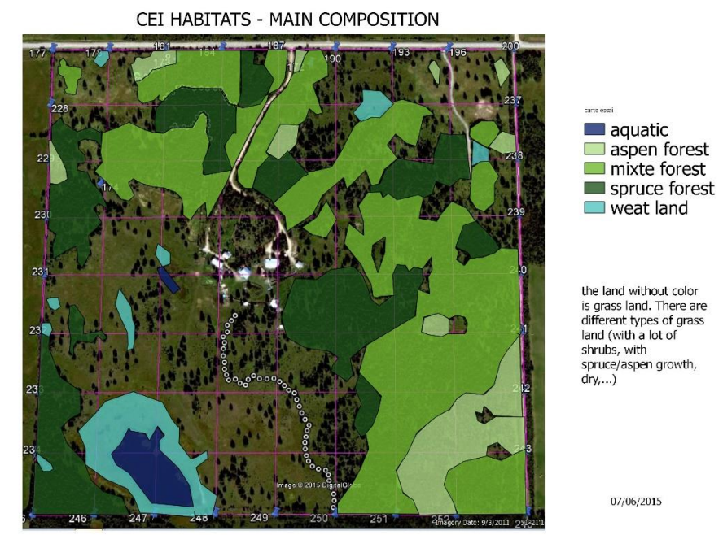
Understanding which habitat biome(s) the bat species at CEI prefer will help understand the behavior patterns of the species and can allow for predictions on locations and roosting and/or hibernation sights.

Objectives
- Investigating the timing of return to activity (from migration or hibernation) of the nine bat species in the province Alberta in Canada.
    - To better understand the behavioral patterns of these species and allow scientists to further their research and knowledge about these bat species.
- Investigating which of the five habitat biomes present at Cochrane Ecological Institute the (nine) bat species at CEI use for roosting, foraging/feeding, and/or passing routes.
    - To better understand the behavioral patterns of these species and allow for predictions on locations and roosting/hibernation sights as well as feeding locations to be made.
- Investigating if temperature, wind speeds, and precipitation have an effect on bat activity at the Cochrane Ecological Institute.

Materials & Method

Materials
To be able to complete this research investigation and answer the objectives about the bat species in the Alberta province in Canada, different types of equipment are needed.
Song Meter Mini Bat with App
The song meter mini bat recorder from Wildlife Acoustics (Wildlife Acoustics, n.d.) was used to record the calls of the bat species present on the grounds of the Cochrane Ecological Institute along with the accompanying iPhone app. In Appendix I the settings for this recorder can be found, with explanations for the reasoning behind choices regarding the settings. The app was used to change the settings of the song meter mini bat.
SD Cards and Batteries
The SD cards and batteries were used to support the sound recorder during the data collection period. An SD card with 512GB storage space was used to store the recorded sounds and was capable of storing up to 10 days of recordings. The batteries that were used were Ni Cad batteries.
Computer
A CEI research computer was used to store and analyse the collected data. These analyses were done using the Kaleidoscope Pro Software from Wildlife Acoustics, which works in combination with the song meter mini bat recorder and allowed for identification and further analysis of the bat species recorded.
iPhone
The iPhone was used to find the coordinates of placement for the song meter mini bat recorder in the correct habitat biomes. It was also used to change the settings for the song meter mini bat recorder using the app that comes with the recorder.
Kaleidoscope Pro Software
The Kaleidoscope Pro Software from Wildlife Acoustics (Wildlife Acoustics, n.d.) was used to identify the bat species from their calls recorded with the song meter mini bat recorder.
Excel
The Microsoft Excel program was used to organize and analyse the results after processing the bat recordings in Kaleidoscope. The collected weather data was also stored in a Microsoft Excel document.
Google Maps
Google maps will be used on the iPhone to determine the coordinates of the song meter mini bat recorder placement.

Method
To collect the data required to answer the research questions, there are several methodological steps needed to ensure trustworthy results.
Song Meter Mini Bat Recorder Methodology (Initial Location)
- Remove song meter mini bat recorder from Wildlife Acoustics casing.
- Insert Ni Cad batteries and 512GB SD card into recorder.
- Use song meter mini bat quick start guide to start up the recorder and pair it with the song meter app on the phone (Wildlife Acoustics, n.d.).
- Change the settings of the song meter mini bat to the required settings noted and explained in Appendix I via the song meter app on the iPhone.
- Locate the initial recording location for recording the sounds of returning bats from migration or awakening bats from hibernation.
- Secure the song meter mini bat to a secure standing (ie. A post/scaffolding/tree).
- Record every night from sunset to sunrise (scheduled recording in the song meter mini bat app settings).
- Replace the Ni Cad batteries every 4 nights.
- Collect 512GB SD card after 8 nights.
- Download the data from the SD card onto the computer, format the SD card, and replace the SD card in the recorder.
- Upload the downloaded sound recordings from the SD card to the Kaleidoscope Pro Software on the computer.
- Analyse the sound recordings of the bat calls using the Kaleidoscope Pro Software on the computer.
- Repeat steps 5 – 12 until bat calls are being recorded.
- Once bat calls are recorded, continue recording for 4 more nights.
Song Meter Mini Bat Recorder Methodology (Habitat Biomes)
This methodology assumes that the initial set up for the song meter mini bat recorder has already been completed and the song meter mini bat is ready for use.
- Select habitat biome.
- Locate coordinates for securing song meter mini bat for recording the sounds of present bat species in the habitat biome.
- Secure song meter mini bat to a secure standing (ie. A post/scaffolding/tree).
- Record for 8 nights from sunset to sunrise (scheduled recording in the song meter mini bat app settings).
- Replace the Ni Cad batteries every 4 nights.
- Collect 512GB SD card after 8 nights.
- Download the data from the 512GB SD card onto the computer and replace the SD card in the recorder.
- Upload the download sound recordings from the 512GB SD card to the Kaleidoscope Pro Software on the computer.
- Analyse the sound recordings of the bat calls using the Kaleidoscope Pro Software on the computer.
- Identify the bat species using the Kaleidoscope Pro Software on the computer.
- Repeat steps 1 – 10 for each habitat biome.
Analyses Methodology
- Download the identified sound recordings from Kaleidoscope to an Excel document.
- Create a table with date, time, hour, species ID, and habitat.
- Create a series of pivot tables to examine the data.
- Select the headings.
- Select data -> filter.
- Select the entire table.
- Select insert -> pivot table -> from table/range.
- Insert date and hour into row fields.
- Insert species ID and habitat into column fields.
- Insert species ID (count) into value fields.

Time Frame
Table 3: Time Frame and Additional Information for Data Collection
24.04.2022 | Testing recorder  - Placed the recorder at coordinates (51.3548107, -114.5931325) for two nights  - Collect SD card and upload data to Kaleidoscope  - Analyse recordings to see if the recorder recorded sounds and recorded during the correct times
10.05.2022 – 26.05.2022 | Place recorder in initial location (coordinates: 51.3546201, -114.5949782)
29.05.2022 – 12.06.2022 | Place recorder in spruce forest habitat biome (coordinates: 51.3546113, -114.5929394)
12.06.2022 – 26.06.2022 | Place recorder in mixed forest habitat biome (coordinates: 51.3561048, -114.5943644)
26.06.2022 – 10.07.2022 | Place recorder in aspen forest habitat biome (coordinates: 51.3570474, -114.5936204)
10.07.2022 -17.07.2022 | Place recorder in wetland habitat biome (coordinates: 51.3523339, -114.5959026)
17.07.2022 -23.07.2022 | Place recorder in aquatic habitat biome (coordinates: 51.3546744, -114.5958439)

Data Analysis
The song meter mini bat recorder was initially placed in the coordinates mentioned in table 3 under Time Frame. This is a central location on the Cochrane Ecological Institute grounds. This location was used to record the initial appearance of the different bat species present in Alberta. In Table 4 the number of bat calls recorded in the initial location are presented. The first species that arrives, on the 21st of May 2022, is the Eastern Red Bat (Lasiurus borealis). However, as it only appears on the 21st and 22nd of May 2022, and does not appear again in the initial location, it is questionable if this is reliable. Another possibility is that the bat species was just migrating/passing through the area to its final destination.
On the 23rd of May 2022, the Big Brown Bat (Eptesicus fuscus), the Hoary Bat (Lasiurus cinereus), the Silver-Haired Bat (Lasionycteris noctivagans), and the Western Small-Footed Myotis (Myotis ciliolabrum) make their first appearance. The Hoary Bat (Lasiurus cinereus) has the highest number of calls recorded on this night, with the Silver-Haired Bat (Lasionycteris noctivagans) second. These species both migrate (Hoary Bat, Silver-Haired Bat) and hibernate (Big Brown Bat, Hoary Bat, Silver-Haired Bat, Western Small-Footed Myotis) during the winter months.
The number of bats that are present on the 24th of May 2022 increase. The bat species that were present on the night of the 23rd of May 2022 are also present on the 24th with the addition of the Little Brown Bat (Myotis lucifugus) and the Long-Legged Myotis (Myotis volans). These two additional species hibernate in the winter months.
The two bat species that do not make an appearance at the initial location are the Western Long-Eared Myotis (Myotis evotis) and the Northern Long-Eared Myotis (Myotis septentrionalis). From this data, it can be assumed that these species have a later wake up time from their hibernation. Based on table 4, the other bat species can be expected to return to activity from the middle of May.
Table 4: Number of total bat calls recorded in initial locations (coordinates: 51.3546201, -114.5949782) per day of recording
Dates | Big Brown Bat (Eptesicus fuscus) | Eastern Red Bat (Lasiurus borealis) | Hoary Bat (Lasiurus cinereus) | Silver-Haired Bat (Lasionycteris noctivagans) | Western Small-Footed Myotis (Myotis ciliolabrum) | Western Long-Eared Myotis (Myotis evotis) | Little Brown Bat (Myotis lucifugus) | Northern Long-Eared Myotis (Myotis septentrionalis) | Long-Legged Myotis (Myotis volans)
21-5-2022 | 0 | 1 | 0 | 0 | 0 | 0 | 0 | 0 | 0
22-5-2022 | 0 | 1 | 0 | 0 | 0 | 0 | 0 | 0 | 0
23-5-2022 | 6 | 0 | 14 | 8 | 1 | 0 | 0 | 0 | 0
24-5-2022 | 26 | 0 | 18 | 5 | 4 | 0 | 1 | 0 | 5
25-5-2022 | 5 | 0 | 3 | 3 | 0 | 0 | 1 | 0 | 0
26-5-2022 | 3 | 0 | 0 | 3 | 4 | 0 | 0 | 0 | 0

Table 5 shows where the different bat species made their first appearance. For most of the bat species it was in the initial location of recording. However, for the two bat species that returned to activity later, the Western Long-Eared Myotis (Myotis evotis) and the Northern Long-Eared Myotis (Myotis septentrionalis), their first appearances were in the spruce forest habitat biome and the mixed forest habitat biome respectively.
Table 5: First Appearance of the Different Bat Species and in Which Habitat They Appeared
Species | Date First Noted | Habitat
Big Brown Bat (Eptesicus fuscus) | 23-5-2022 | Initial location
Eastern Red Bat (Lasiurus borealis) | 21-5-2022 | Initial location
Hoary Bat (Lasiurus cinereus) | 23-5-2022 | Initial location
Silver-Haired Bat (Lasionycteris noctivagans) | 23-5-2022 | Initial location
Western Small-Footed Myotis (Myotis ciliolabrum) | 23-5-2022 | Initial location
Western Long-Eared Myotis (Myotis evotis) | 2-6-2022 | Spruce forest habitat biome
Little Brown Bat (Myotis lucifugus) | 24-5-2022 | Initial location
Northern Long-Eared Myotis (Myotis septentrionalis) | 13-6-2022 | Mixed forest habitat biome
Long-Legged Myotis (Myotis volans) | 24-5-2022 | Initial location

Shown in table 6 is the total number of calls per bat species per habitat biome recorded during the whole recording period.
The Big Brown Bat (Eptesicus fuscus) spends most of its time in the aquatic and wetland habitat biomes. With 148 calls in the aquatic habitat biome and 133 calls in the wetland habitat biome. In total there were 452 Big Brown Bat calls on the Cochrane Ecological Institute property. This shows that the Big Brown Bat most likely uses the wetland and aquatic habitats for most of its daily activities; foraging, feeding, and resting.
The Eastern Red Bat (Lasiurus borealis) spends most of its time in the aquatic and aspen forest habitat biomes, with 65 and 67 bat calls in each habitat biome, respectively. It spends the least amount of time in the mixed forest and spruce forest habitat biomes, with only 1 bat call in each biome out of the total 165 calls recorded.
The Hoary Bat (Lasiurus cinereus) has a total of 715 bat calls in the aquatic habitat biome and 394 calls in the wetland habitat biome. The Hoary Bat has the lowest number of bat calls in the mixed habitat biome; 22 calls. The total number of recorded calls for the Hoary Bat is 1367.
The Silver-Haired Bat (Lasionycteris noctivagans) was recorded a total of 691 times over the recording period. From the recordings collected the Silver-Haired Bat spends most of its time in the aquatic (274 bat calls), the wetland (146 bat calls), and the aspen forest (118 bat calls) habitat biomes.
The Western Small-Footed Myotis (Myotis ciliolabrum) has a total of 833 bat calls in the recorded period. Most of these calls, 577 bat calls, were recorded in the aspen forest habitat biome. The Western Small-Footed Myotis spends the least of its time in the spruce forest habitat biome.
The Western Long-Eared Myotis (Myotis evotis) was recorded a total of 97 times in the recorded period, spending most of their time at the mixed forest habitat biome. The least amount of bat calls for the Western Long-Eared Myotis occurred in the wetland habitat biome; 1 bat call.
The Little Brown Bat (Myotis lucifugus) was recorded a total of 364 times. The highest number of bat calls recorded was 148 bat calls in the aquatic habitat biome and 108 bat calls in the aspen forest habitat biome. The least amount of bat calls recorded for the Little Brown Bat was in the mixed forest habitat biome.
The Northern Long-Eared Myotis (Myotis septentrionalis) only has 13 recorded bat calls during the recorded period. The most calls, 9 bat calls, were recorded in the mixed forest habitat biome. 3 bat calls were recorded in the aspen forest habitat biome and 1 bat call was recorded in the wetland habitat biome.
The Long-Legged Myotis (Myotis volans) was recorded a total of 82 times. The Long-Legged Myotis spends most of its time in the aspen and mixed forest habitat biomes, 31 and 35 bat calls respectively.

Table 6: Table showing total calls per species per habitat biome.
 | Aquatic | Aspen Forest | Mixed Forest | Spruce Forest | Wetland | Total Calls Per Species
Big Brown Bat (Eptesicus fuscus) | 148 | 42 | 26 | 63 | 133 | 412
Eastern Red Bat (Lasiurus borealis) | 65 | 67 | 1 | 1 | 29 | 163
Hoary Bat (Lasiurus cinereus) | 715 | 101 | 22 | 100 | 394 | 1332
Silver-Haired Bat (Lasionycteris noctivagans) | 274 | 118 | 36 | 98 | 146 | 672
Western Small-Footed Myotis (Myotis ciliolabrum) | 86 | 577 | 62 | 29 | 70 | 824
Western Long-Eared Myotis (Myotis evotis) | 7 | 26 | 44 | 19 | 1 | 97
Little Brown Bat (Myotis lucifugus) | 145 | 108 | 7 | 9 | 93 | 362
Northern Long-Eared Myotis (Myotis septentrionalis) | 0 | 3 | 9 | 0 | 1 | 13
Long-Legged Myotis (Myotis volans) | 7 | 31 | 35 | 3 | 1 | 77
Total Calls Per Habitat Biome | 1447 | 1073 | 242 | 322 | 868 | 3952

Overview
Graph 1, shown below, shows the total number of bat calls per species per habitat biome. The graph shows that the Hoary Bat (Lasiurus cinereus), has the highest number of bat calls in the aquatic and wetland habitat biomes. In the aspen forest habitat biome, the Western Small-Footed Myotis (Myotis ciliolabrum) has the highest number of bat calls. These three occurrences all have a significantly higher number of bat calls compared to the rest of the species in these habitat biomes.
It is clear from the graph below that the mixed forest and spruce forest habitat biomes are used the least by all the nine species present at the Cochrane Ecological Institute.

Graph 1: Total Number of Bat Calls per Species per Habitat Biome
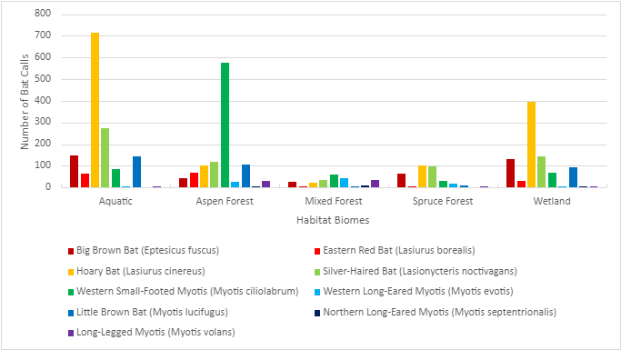

Big Brown Bat (Eptesicus fuscus)
As mentioned in table 6, the Big Brown Bat has the highest number of calls in the aquatic and wetland habitat biome. In graph 2 the big brown bat’s preferences for habitat are shown. The graph shows that the Big Brown Bat prefers the wetter habitat biomes; aquatic and wetland habitats. There is a significant difference between these two habitat biomes and the remaining three habitat biomes. The Big Brown Bat therefore spends most of its time in the open and wet habitat biomes and spends the least amount of its time in the forest habitat biomes.
Graph 2: Habitat Biome Preferences for the Big Brown Bat (Eptesicus fuscus)
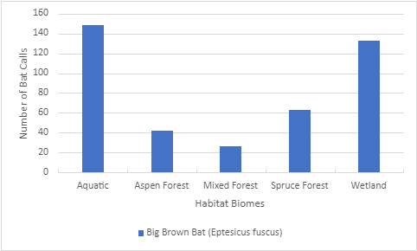

Eastern Red Bat (Lasiurus borealis)
As mentioned in table 6, the Eastern Red Bat has the highest number of bat calls in the aspen forest habitat biome; 67 bat calls. From the graph below, graph 3, the aspen forest habitat biome and the aquatic habitat biome are the two locations where the Eastern Red Bat spends most of its time. This bat species spends the least amount of its time in the mixed and spruce forest habitat biome.
Graph 3: Habitat Biome Preferences for the Eastern Red Bat (Lasiurus borealis)
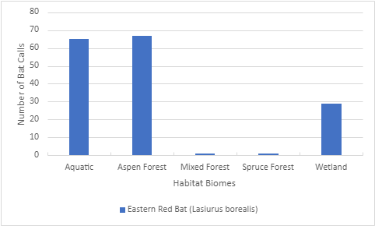

Hoary Bat (Lasiurus cinereus)
As mentioned in table 6, the highest number of recorded bat calls for the Hoary Bat occurred in the aquatic habitat biome. This species spends the least amount of time in the mixed forest habitat biome. The graph below, graph 4, indicates that the Hoary Bat spends the least amount of its time in the forest habitat biomes. It prefers the wetter habitat biomes, like the aquatic and the wetland habitat biomes.

Graph 4: Habitat Biome Preferences for the Hoary Bat (Lasiurus cinereus)
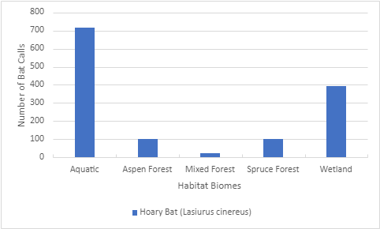

Silver-Haired Bat (Lasionycteris noctivagans)
As mentioned in table 6, the highest number of bat calls for the Silver-Haired Bat was recorded in the aquatic biome. Graph 5 indicates that the Silver-Haired Bat spends most of its time in the aquatic habitat biome. It spends some of its time in the forest habitat biomes, specifically the aspen and spruce forest habitat biomes. But the main preference of habitat biome for the Silver-Haired Bat remains the aquatic habitat biome.
Graph 5: Habitat Biome Preferences for the Silver-Haired Bat (Lasionycteris noctivagans)
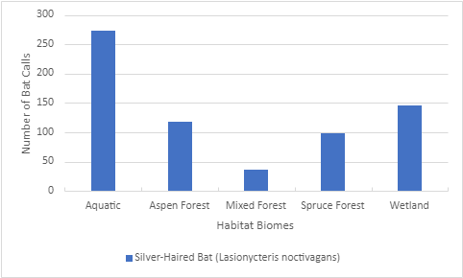

Western Small-Footed Myotis (Myotis ciliolabrum)
As mentioned in table 6, the Western Small-Footed Myotis spends most of its time in the aspen forest habitat biome. Graph 6 shows that the Western Small-Footed Myotis spends most of its time in the aspen forest habitat biome. It doesn’t spend its time in any of the other locations, which all recorded under 100 bat calls whereas the number of recorded bat calls in the aspen forest reached almost 600 bat calls.
Graph 6: Habitat Biome Preferences for the Western Small-Footed Myotis (Myotis ciliolabrum)
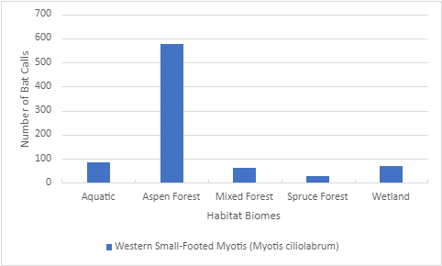

Western Long-Eared Myotis (Myotis evotis)
As mentioned in table 6, The Western Long-Eared Myotis has the highest number of recorded bat calls in the mixed forest habitat biome; 44 bat calls out of the total 97 bat calls recorded. The Western Long-Eared Bat spends most of its time in the forest habitat biomes, as shown in graph 7, and tends to avoid the wetter habitat biomes; the aquatic and wetland habitat biomes.
Graph 7: Habitat Biome Preferences for the Western Long-Eared Myotis (Myotis evotis)
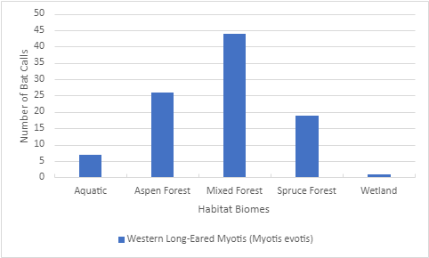

Little Brown Bat (Myotis lucifugus)
As mentioned in table 6, the Little Brown Bat spends most of its time in the aquatic habitat biome, where 145 bat calls were recorded for this species. Besides the aquatic habitat biome, the Little Brown Bat spent time in the aspen forest habitat biome and the wetland habitat biome, as shown in graph 8 below. It spends the least amount of its time in the mixed forest and spruce forest habitat biomes, with 7 and 9 bat calls recorded in each respectively.
Graph 8: Habitat Biome Preferences for the Little Brown Bat (Myotis lucifugus)
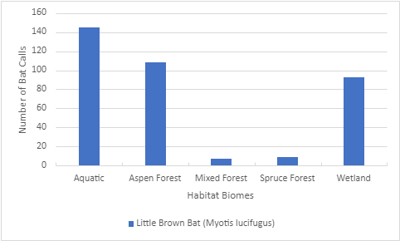

Northern Long-Eared Myotis (Myotis septentrionalis)
As mentioned in table 6, the Northern Long-Eared Myotis was recorded a total of 13 times in all the habitat biomes, with the most recorded in the mixed forest habitat biome, with 9 recorded calls. The Northern Long-Eared Myotis was recorded the least number of times out of all the bat species present at the Cochrane Ecological Institute. It was recorded once in the wetland habitat biome. The Northern Long-Myotis was not recorded in the aquatic and spruce forest habitat biome.
Graph 9 shows the preferences of the Northern Long-Eared Myotis. This species spends most of its time in mixed forest habitat biome with 9 bat calls recorded. However, from the limited number of total recordings for the Northern Long-Eared Myotis, there isn’t enough reliable data to make a clear and reliable conclusion about the preferences for this species.

Graph 9: Habitat Biome Preferences for the Northern Long-Eared Myotis (Myotis septentrionalis)
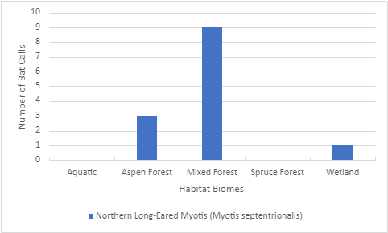

Long-Legged Myotis (Myotis volans)
As mentioned in table 6, the highest number of bat calls recorded for the Long-Legged Myotis was in the mixed forest habitat biome with 35 calls recorded. The least number of calls recorded was in the wetland habitat biome, with 1 call recorded. With 31 calls, the Long-Legged Myotis also spends a significant amount of its time in the aspen forest habitat biome, as shown in graph 10 below.
Graph 10: Habitat Biome Preferences for the Long-Legged Myotis (Myotis volans)
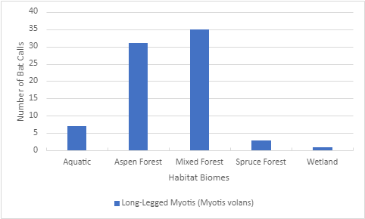

Weather
In graph 11, shown below, it shows the number of bat calls for each species within the aquatic habitat biome in comparison to the average temperatures and wind speeds during activity for each species. The weather data was created through averaging the total hourly temperature, wind speed, and precipitation recordings. The Northern Long-Eared Myotis (Myotis septentrionalis) was not included in this graph because it was not recorded in the aquatic habitat biome. The average precipitation amounts (mm/h) are also not shown on this graph because all species have an average of 0 millimeters of precipitation per hour.
From the graph the Myotis species of bats have a lower average temperature in which they are active compared to the other species. It is between one and two degrees Celsius lower than the other species. The Hoary Bat (Lasiurus cinereus) has an average temperature of 14 degrees Celsius during its active hours. It has the highest average temperature out of all the bat species when present in the aquatic habitat biome.
A similar trend can be seen for the average wind speeds (km/h). The Myotis species of bats have a lower average wind speed compared to the other species, with a range between 8 and 10 kilometers per hour. The Eastern Red Bat (Lasiurus borealis) also has a lower average wind speed during its active hours, about 10 kilometers per hour. The highest recording average wind speeds in the aquatic habitat biome belong to the Hoary bat (Lasiurus cinereus) and the Big Brown Bat (Eptesicus fuscus).

Graph 11: Comparison Between Number of Bat Calls Per Species, Average Temperatures (°C), and Average Wind Speeds (km/h) in the Aquatic Habitat Biome
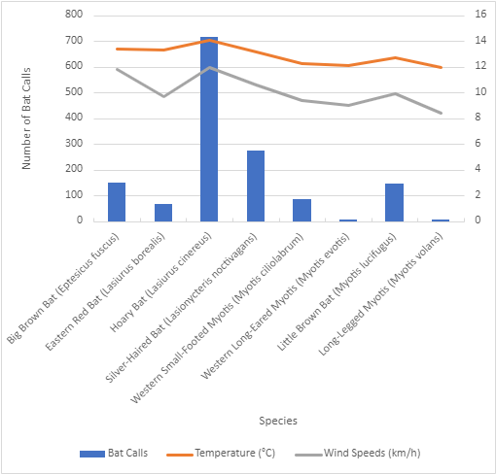

Graph 12, shown below, shows the comparison of the number of bat calls in the aspen forest habitat biome and the average temperatures (°C) and winds speeds (km/h) for the active hours for the different bat species. The weather data was created through averaging the total hourly temperature, wind speed, and precipitation recordings. The average precipitation (mm/h) is not shown on the graph because the averages are 0 millimeters per hour for all the bat species.
The graph shows that the Western Long-Eared Myotis (Myotis evotis) has the lowest average temperature and lowest average wind speed during its active hours with 9 degrees Celsius average temperatures and 6 km/h average wind speeds. The highest average temperatures are recorded for the Hoary Bat (Lasiurus cinereus) during its active hours. The highest average wind speeds are recorded for the Hoary Bat (Lasiurus cinereus) again and the Little Brown Bat (Myotis lucifugus).
Just like in the aquatic habitat biome, the myotis species in the aspen forest habitat biome have lower average temperatures and wind speeds compared to the other bat species.
Graph 12: Comparison Between Number of Bat Calls Per Species, Average Temperatures (°C), and Average Wind Speeds (km/h) in the Aspen Forest Habitat Biome
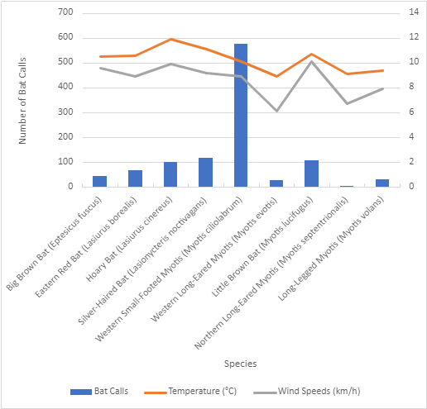

Graph 13, shown below, shows the comparison of the number of bat calls in the mixed forest habitat biome and the average temperatures (°C), winds speeds (km/h), and precipitation (mm/h) for the active hours for the different bat species. The weather data was created through averaging the total hourly temperature, wind speed, and precipitation recordings. All nine bat species were recorded in this habitat. The average temperatures range from 8 degrees Celsius to 10 degrees Celsius. The wind speeds range from 9 km/h to 13 km/h.
The bat species showing activity with the highest recorded average temperature, between 11 and 12 degrees Celsius, are the Big Brown Bat (Eptesicus fuscus), the Hoary Bat (Lasiurus cinereus), and the Little Brown Bat (Myotis lucifugus). The bat species recorded with the highest average wind speed, 13 km/h, was the Northern Long-Eared Myotis (Myotis septentrionalis).
The precipitation levels for the bat species in the mixed forest habitat biome are extremely low, however, the Big Brown Bat (Eptesicus fuscus), the Silver-Haired Bat (Lasionycteris noctivagans), and the Western Small-Footed Myotis (Myotis ciliolabrum) have an average of 0,1 mm/h during their active hours. The Long-Legged Myotis (Myotis volans) has an average of 0,2 mm/h during its active hours
Graph 13: Comparison Between Number of Bat Calls Per Species, Average Temperatures (°C), Average Wind Speeds (km/h), and Average Precipitation (mm/h) in the Mixed Forest Habitat Biome

Graph 14, shown below, shows the comparison of the number of bat calls in the spruce forest habitat biome and the average temperatures (°C), winds speeds (km/h), and precipitation (mm/h) for the active hours for the different bat species. The weather data was created through averaging the total hourly temperature, wind speed, and precipitation recordings. The Northern Long-Eared Myotis (Myotis septentrionalis) is not included in the graph because it was not recorded in this location. The Eastern Red Bat (Lasiurus borealis) was recorded once in the spruce forest habitat biome; therefore, it is included in the graph above, however, it is not visible because of the line graph representing the average precipitation (mm/h) for this habitat biome.
The Eastern Red Bat (Lasiurus borealis), although recorded only once, has the highest average temperature and wind speed during its active hours. It was recorded with 13 degrees Celsius and about 20 km/h wind speed. The remaining bat species have an average wind speed of below 13 km/h. There is a large gap between the wind speeds of the Eastern Red Bat (Lasiurus borealis) and the rest of the bat species in the area.
The Myotis species appear to be more active if there is slight precipitation compared to the other species. Besides the Long-Legged Myotis (Myotis volans), the other Myotis species have an average of 0,1 mm/h precipitation during their active hours.
Graph 14: Comparison Between Number of Bat Calls Per Species, Average Temperatures (°C), Average Wind Speeds (km/h), and Average Precipitation (mm/h) in the Spruce Forest Habitat Biome

Graph 15, shown below, shows the comparison of the number of bat calls in the wetland habitat biome and the average temperatures (°C) and winds speeds (km/h) for the active hours for the different bat species. The weather data was created through averaging the total hourly temperature, wind speed, and precipitation recordings. The average precipitation (mm/h) is not included in the graph above because all species have an average of 0 mm/h for precipitation. The Western Long-Eared Myotis (Myotis evotis), the Northern Long-Eared Myotis (Myotis septentrionalis), and the Long-Legged Myotis (Myotis volans) are included in the graph because they were recorded a total of 1 time in the wetland habitat biome, however this is not visible on the graph.
The Western Long-Eared Myotis (Myotis evotis) and the Long-Legged Myotis (Myotis volans) have a significantly lower wind speed average than the rest of the species, with only about 4 km/h wind speeds recorded during their active hours. The Northern Long-Eared Myotis (Myotis septentrionalis) has the highest average wind speed, 18 km/h. The remaining species have an average wind speed varying between 10 km/h and 13 km/h.
The average temperatures are not as varying as the wind speeds. The averages range from 12 degrees Celsius and 16 degrees Celsius. The highest average temperature was 16 degrees Celsius and was recorded with the Western Long-Eared Myotis (Myotis evotis).
Graph 15: Comparison Between Number of Bat Calls Per Species, Average Temperatures (°C), and Average Wind Speeds (km/h) in the Wetland Habitat Biome

Conclusion
From the data collected during this investigation, it appeared that the Hoary Bat (Lasiurus cinereus) appeared the most on the Cochrane Ecological Institute property. It was recorded a total of 1332 times out of the 3952 total bat calls recorded. There are four other species that were recorded a significant number of times. The Western Small-Footed Myotis (Myotis ciliolabrum) was recorded a total of 824 times. The Silver-Haired Bat (Lasionycteris noctivagans) was recorded a total of 672 times. The Big Brown Bat (Eptesicus fuscus) was recorded a total of 412 times. The Little Brown Bat was recorded a total of 362 times. The species that was recorded the least number of times was the Northern Long-Eared Myotis (Myotis septentrionalis). It was recorded a total of 13 times.
The habitat biome that was used the most was the aquatic habitat biome. There were a total of 1447 calls recorded in this habitat biome. Most of these calls were from the Hoary Bat (Lasiurus cinereus). Besides the aquatic habitat biome, the aspen forest and the wetland habitat biomes were used significantly more than the mixed forest and spruce forest habitat biomes. There were 1073 calls recorded in the aspen forest habitat biome, mainly produced by the Western Small-Footed Myotis (Myotis ciliolabrum). In the wetland habitat biome, a total of 868 calls were recorded, mainly produced by the Hoary Bat (Lasiurus cinereus).
The weather data recorded showed that the bats prefer dry days with the least amount of precipitation (mm/h). The precipitation data ranged from 0 to 0,2 mm/h, with most of the bats being active during days with 0 mm precipitation per hour. The average hourly temperatures ranged from 8 to 16 degrees Celsius. The bats showed a preference for temperatures ranging from 10 to 14 degrees Celsius. The average wind speeds (km/h) ranged from 4 to 20 kilometers per hour. Most of the average wind speeds recorded were below 16 kilometers per hour. Milder winds are preferable for the bats and the bats will not show themselves with extremely high wind speeds.

Return to Activity
As mentioned earlier in this investigation report, the bat recorder was placed in the center of the Cochrane Ecological Institute property to get insight into the initial arrival of the nine bat species. The first objective of this investigation rings as follows:
Investigating the timing of return to activity (from migration or hibernation) of the nine bat species in the province Alberta in Canada to better understand the behavioral patterns of these species and allow scientists to further their research and knowledge about these bat species.
After collecting the data regarding this objective, it was found that the nine bat species return to activity near the end of May (from the 22nd of May) or the beginning of June (for two of the nine species; the Western Long-Eared Myotis (Myotis evotis) from the 6th of July and the Northern Long-Eared Myotis (Myotis septentrionalis) from the 13th of July).

Habitat Biome Usage
The second objective of this investigation rings as follows:
Investigating which of the five habitat biomes present at Cochrane Ecological Institute the (nine) bat species at CEI use for roosting, foraging/feeding, and/or passing routes to better understand the behavioral patterns of these species and allow for predictions on locations and roosting/hibernation sights as well as feeding locations to be made.
The table below, table 7, shows which bats use which habitat biomes the most. The aquatic habitat biome and the aspen forest habitat biome are used the most by the bat species present. Seven out of the nine species use either the aquatic or the aspen forest habitat biome. The mixed forest habitat biome and the wetland habitat biome are also used, but in a lesser abundance. Five out of the nine species use either the mixed forest or wetland habitat biome, often in combination with the aquatic or aspen forest habitat biomes.
Table 7: Preferred Habitat Biome Usage by the Nine Different Bat Species Present at the Cochrane Ecological Institute
Bat Species | Preferred Habitat Biome Usage
Big Brown Bat (Eptesicus fuscus) | Aquatic habitat biome  Wetland habitat biome
Eastern Red Bat (Lasiurus borealis) | Aquatic habitat biome  Aspen forest habitat biome
Hoary Bat (Lasiurus cinereus) | Aquatic habitat biome  Wetland habitat biome
Silver-Haired Bat (Lasionycteris noctivagans) | Aquatic habitat biome
Western Small-Footed Myotis (Myotis ciliolabrum) | Aspen forest habitat biome
Western Long-Eared Myotis (Myotis evotis) | Mixed forest habitat biome
Little Brown Bat (Myotis lucifugus) | Aquatic habitat biome  Aspen forest habitat biome
Northern Long-Eared Myotis (Myotis septentrionalis) | Mixed forest habitat biome
Long-Legged Myotis (Myotis volans) | Aspen forest habitat biome  Mixed forest habitat biome

Weather Effect
The third objective of this investigation rings as follows:
Investigating if temperature, wind speeds, and precipitation have an effect on bat activity at the Cochrane Ecological Institute.
The graphs made to determine if weather had an effect on the activity of the bat species, we can conclude that the precipitation levels had an impact on bat activity. Due to almost all the precipitation weather data being close to 0 mm per hour, it can be concluded that the bat activity significantly decreases during hours with greater precipitation. As there were nights during the recording process that had precipitation, with no bat activity recorded. The temperatures ranged between 8 and 16 degrees Celsius. It can be concluded that bat activity increases when the temperatures are higher. When the temperatures are below 10 degrees Celsius, bat activity drops steadily. The wind speeds varied more, however, higher wind speeds usually meant a drop in bat activity. Bat activity though was not affected by milder wind speeds.

Limitations
While collecting data there were three limitations that might have had an impact on the data. When collecting the weather data, the Canadian government website for historical data (Government of Canada, 2022) was used with the Calgary Springbank A station. However, for some of the dates that recordings were made, the weather data was missing. To solve this, another station was used on the same website, the Canada Olympic Park station. Both stations share similar elevations, therefore hoping to minimize any differences that may occur. However, due to this, some of the weather data might not be accurate.
Another limitation that occurred during this investigation. While using the sound recordings, it is not possible to determine the number of individual bats that are present for each species. It can only be used to determine whether the bat species are present in an area or not. Therefore, this investigation cannot give an estimate about the number of individual bats per species that are present on the property of the Cochrane Ecological Institute.
The third limitation of this investigation was that there was only one bat recorder available. Because of this the biomes were recorded during different periods of times. If there was access to multiple bat recorded, comparisons could have been made for bat activity in the different biomes in the same period of time.

Further Research
To further this investigation and the research done within it, there are a number of opportunities. An example of further research into the topic of this investigation would be to continue the recordings for an entire summer period to see at which point in the year the different bat species return into hibernation or start their migration back to their wintering homes.
Another opportunity to further the research done in this investigation is to focus on one species at a time in one or more habitat biomes and take more care in finding out which habitat biomes the bat species uses for different purposes. For example, to look into which habitat biome one of the bat species uses for foraging or feeding, for resting, and for passing through. This would allow researchers to understand the usage of each habitat biome better and why the bat species use the habitat biomes more frequently or less frequently.

Works Cited
Alberta Community Bat Program. (n.d.). The bats of Alberta. Retrieved May 12, 2022, from Alberta Community Bat Program A Program of WCS Canada: https://www.albertabats.ca/batprofiles/#:~:text=Their%20migratory%20behaviour%20is%20poorly,when%20they%20reach%20these%20locations.&text=Eastern%20Red%20Bats%20are%20medium,wings%20for%20high%2C%20fast%20flights.).
Burgar, J. M. (2021). North American Bat Monitoring Program, Alberta 2020. Alberta, Canada: Alberta Environment and Parks. Retrieved May 11, 2022, from https://www.albertaebat.ca/static/doc/NABat_2020_Annual_Report_FINAL.pdf
Clara, S. (2015). Report of Cochrane Ecological Institut Area Studie About His Ability to Welcome the Species "Rangifer Tarandus" (Caribou) for Rehabilitation in Alberta. Cochrane Ecological Institute Research. Alberta, Canada. Retrieved May 17, 2022, from https://ceiwildlife.org/intern-reports/.
Government of Canada. (2022). Historical Data. Retrieved August 17, 2022, from https://climate.weather.gc.ca/historical_data/search_historic_data_e.html.
Harvey, M. J., Altenbach, J. S., & Best, T. L. (2011). Bats of the United States and Canada. Baltimore, Maryland, United States: The Johns Hopkins University Press. Retrieved May 12, 2022
Loeb, S. C., Rodhouse, T. J., Ellison, L. E., Lausen, C. L., Reichard, J. D., Irvine, K. M., . . . Johnson, D. H. (2015). A Plan for the North American Bat Monitoring Program (NABat). Southern Research Station. Asheville, Canada: United States Department of Agriculture Forest Service. Retrieved May 11, 2022, from https://www.srs.fs.usda.gov/pubs/gtr/gtr_srs208.pdf
NABat. (2018). Bats We Monitor. Retrieved May 13, 2022, from NABat North American bat Monitoring Program: https://www.nabatmonitoring.org/bats
NABat. (n.d.). Big Brown Bat. Retrieved May 13, 2022, from NABat North American Bat Monitoring Program: https://www.nabatmonitoring.org/eptesicus-fuscus
NABat. (n.d.). What is so special about bats? Retrieved May 12, 2022, from NABat North American Bat Monitoring Program: (https://www.nabatmonitoring.org/why-are-bats-important
Wildlife Acoustics. (n.d.). Kaleidoscope Pro Analysis Software. Retrieved May 26, 2022, from https://www.wildlifeacoustics.com/products/kaleidoscope-pro.
Wildlife Acoustics. (n.d.). Song Meter Mini Bat Ultrasonic Recorder. Retrieved May 15, 2022, from https://www.wildlifeacoustics.com/products/song-meter-mini-bat.
Wildlife Acoustics. (n.d.). Song Meter Mini Quick Start. Retrieved May 15, 2022, from https://www.wildlifeacoustics.com/uploads/user-guides/Song-Meter-Mini-EN-08122022.pdf.

Appendix I: Settings for song meter mini bat recorder
Ultrasonic settings
- Recording format: full spectrum
- Full spectrum sample rate: 256 kHz
- This is the lowest sample rate that is available on the song meter mini bat recorder. As the sounds emitted by the bats range between 20-60 kHz (appendix II), it is not necessary to record anything higher than 256 kHz.
- Minimum trigger frequency: 18 kHz
- Since the lowest call a bat species emits is just below 20, it was decided to place the minimum trigger frequency to 18 kHz to make sure that all potential bat noises were accounted for and recorded.
- Maximum recording length: 10 secs
- Most bat calls do not last lang, therefore it is not necessary to record for long periods of time. It was decided to use 10 seconds to be able to catch a sequence of calls emitted by one bat, and not miss any calls.
- Trigger window: 3 secs
- Having a 3 second window means that once three seconds have passed without a sound detected, the recording will stop, even if the 10 seconds have not been reached. This reduces the amount of empty recordings produced.
- Save noise files: no
- Deleting noise files makes it possible to quicker analyse and determine if the sounds are indeed bat calls. When a sound is produced that is certainly not a bat species call, it will be ignored.
- Left channel gain: 12 dB
- Default setting
Acoustic settings
- Sample rate: 24000 Hz
- Default setting
- Maximum recording length: 60 mins
- Default setting
- Right channel gain: 18 dB
- Default setting
Location & time zone
- Location to address: 51061 Township Rd 280, Rocky View County, AB T01 Alberta
- Latitude: 51.35489
- Longitude: 114.59312
- Select time zone: UTC – 6:00
Delay start
- 22.04.2022
- It is expected that the weather warms up around this time of the month, therefore the bat recorder will be put out at the initial location to be able to catch the first bat species coming out of hibernation or returning from their migration destinations.
Record from sunset to sunrise

Appendix II: Call frequency of the bat species expected in the province Alberta, Canada
Table 3: Call frequency of the bat species expected in the province Alberta, Canada
 | Common name | Scientific Name | Call Frequency (kHz)
1 | Big brown bat | Eptesicus fuscus | ~ 30
2 | Eastern red bat | Lasiurus borealis | ~ 38 - 50
3 | Hoary bat | Lasiurus cinereus | ~ 20
4 | Little brown bat | Myotis lucifugus | ~ 40
5 | Long-legged myotis | Myotis volans | ~ 40
6 | Northern long-eared myotis | Myotis septentrionalis | ~ 40
7 | Silver-haired bat | Lasionycteris noctivagans | ~ 30
8 | Western long-eared myotis | Myotis evotis | ~ 30
9 | Western small-footed myotis | Myotis ciliolabrum | ~ 45

Sources used:
NABat Monitoring. (n.d.). Eptesicus fuscus. Retrieved May 14, 2022, from https://www.nabatmonitoring.org/eptesicus-fuscus.
NABat Monitoring. (n.d.). Lasionycteris noctivagans. Retrieved May 14, 2022, from https://www.nabatmonitoring.org/lasionycteris-noctivagans.
NABat Monitoring. (n.d.). Lasiurus borealis. Retrieved May 14, 2022, from https://www.nabatmonitoring.org/lasiurus-borealis.
NABat Monitoring. (n.d.). Lasiurus cinereus. Retrieved May 14, 2022, from https://www.nabatmonitoring.org/lasiurus-cinereus.
NABat Monitoring. (n.d.). Myotis evotis. Retrieved May 14, 2022, from https://www.nabatmonitoring.org/myotis-evotis.
NABat Monitoring. (n.d.). Myotis lucifugus. Retrieved May 14, 2022, from https://www.nabatmonitoring.org/myotis-lucifugus.
NABat Monitoring. (n.d.). Myotis septentrionalis. Retrieved May 14, 2022, from https://www.nabatmonitoring.org/myotis-septentrionalis.
NABat Monitoring. (n.d.). Myotis volans. Retrieved May 14, 2022, from https://www.nabatmonitoring.org/myotis-volans.
Animal Diversity. (n.d.). Myotis ciliolabrum. Retrieved May 14, 2022, from https://animaldiversity.org/accounts/Myotis_ciliolabrum/.

